#### Purpose of implementing ZCFPERFCHECK_V1

The purpose of ZCFPERFCHECK_V1 is to extract data from an AS ABAP system that can be used for further anlysis to determine if there are:

1. Any issues with the Z programs in the system.
2. Any performance issues in the system that might be caused by specific Z programs.

#### Implementation steps

Note:

* Please use the naming convention provided in the document and ignore the naming in the screenshots.
* If there is any specific naming conventions that need to be followed in your system, please adapt the naming to follow your convention.
* If you are required to assign development objects to local packages then you can jump to step 2 and just specify Local Object when asked for the package.

1. In transaction SE80, create a new package called ZCFPERFCHECK_V1.

Click Yes to create the package

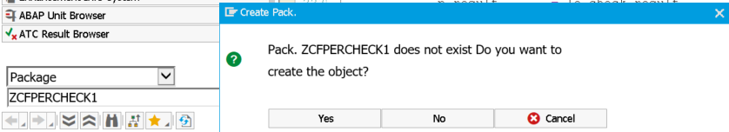

Fill in the fields as required

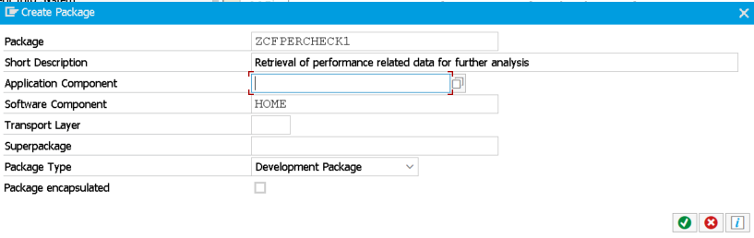

Specify a transport request

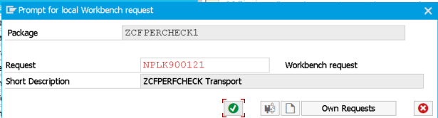

1. In SE80, create a new program called ZCFPERFCHECK_V1 and assign it to the package created in step 1.

Click Yes

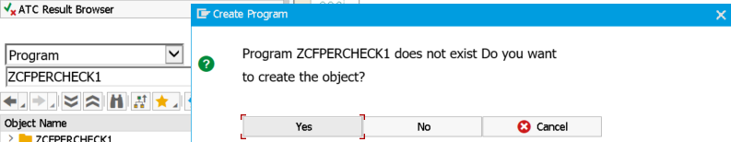

Specify the program name

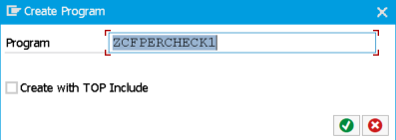

Specify the title and set the Status to Test Program

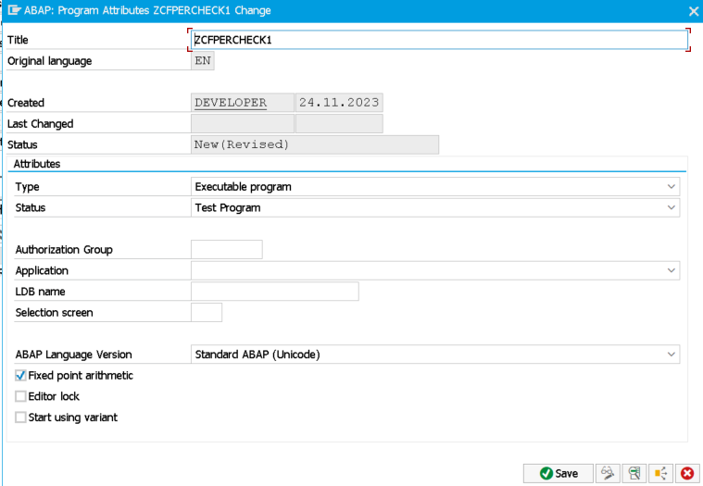

Specify the package name, or choose Local Object if it should not be assigned to a package

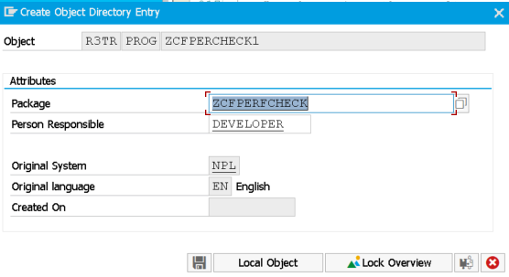

If you have chosen to save it to a package, please specify the transport request that the package has been assigned to

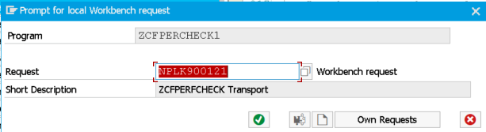

1. Double click on ZCFPERFCHECK_V1 under Object name in order to add the provided source code.

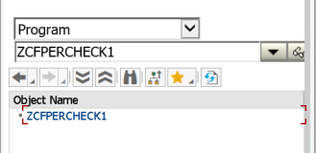

1. Save the program and execute a check to verify that there are no errors produces in your system. If there are any errors, please let me know.

Ctrl+F2 or the Check button on the left of the Activate button.

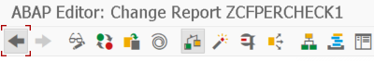

1. Under the constants section you will find values that can be adjusted. The following values should be adjusted based on your system usage policies

**gc_kpi_ci_programs_to_analyze** has been set to a value that ensures that only Z programs are analyzed. If you have a specific Z program that needs to be analyzed then you can replace Z% to the program name itself.

**gc_kpi_job_runtime_in_sec** can be adjusted to retrieve information on background jobs where Z programs are executed that run longer than a minimum amount of time in seconds

**gc_file_download_path** indicates the location that the output file will be saved to and this should be changed to a location where you are able to download files to.

**gc_download_source_code** can be set to **yes** or **no**. If there is a policy against downloading the Z program source code and providing the content to a third party, then please set this value to **no** to ensure no source code is downloaded.

The rest of the values can be left as is, unless you have a specific convention that you need to follow.

1. Activate (Ctrl+F3) and Execute (F8) the program.





Please note that the execution of the program can take a while, depending on how many Z programs need to be analyzed in the system

Click Allow to download the output file that has been generated. This is the file that I will need in order to check for any issues with the Z program and any long running background jobs that are executing the Z programs.

